Practical 15 Inheritance

- Create the following classes. In the Computer class declare count as
private static int count, include gets and sets for each property. Try using the code generator. In the constructor increment count.
In the App class create an instance of Computer and two instances of Laptop, printout the getCount() method, it should return 3.
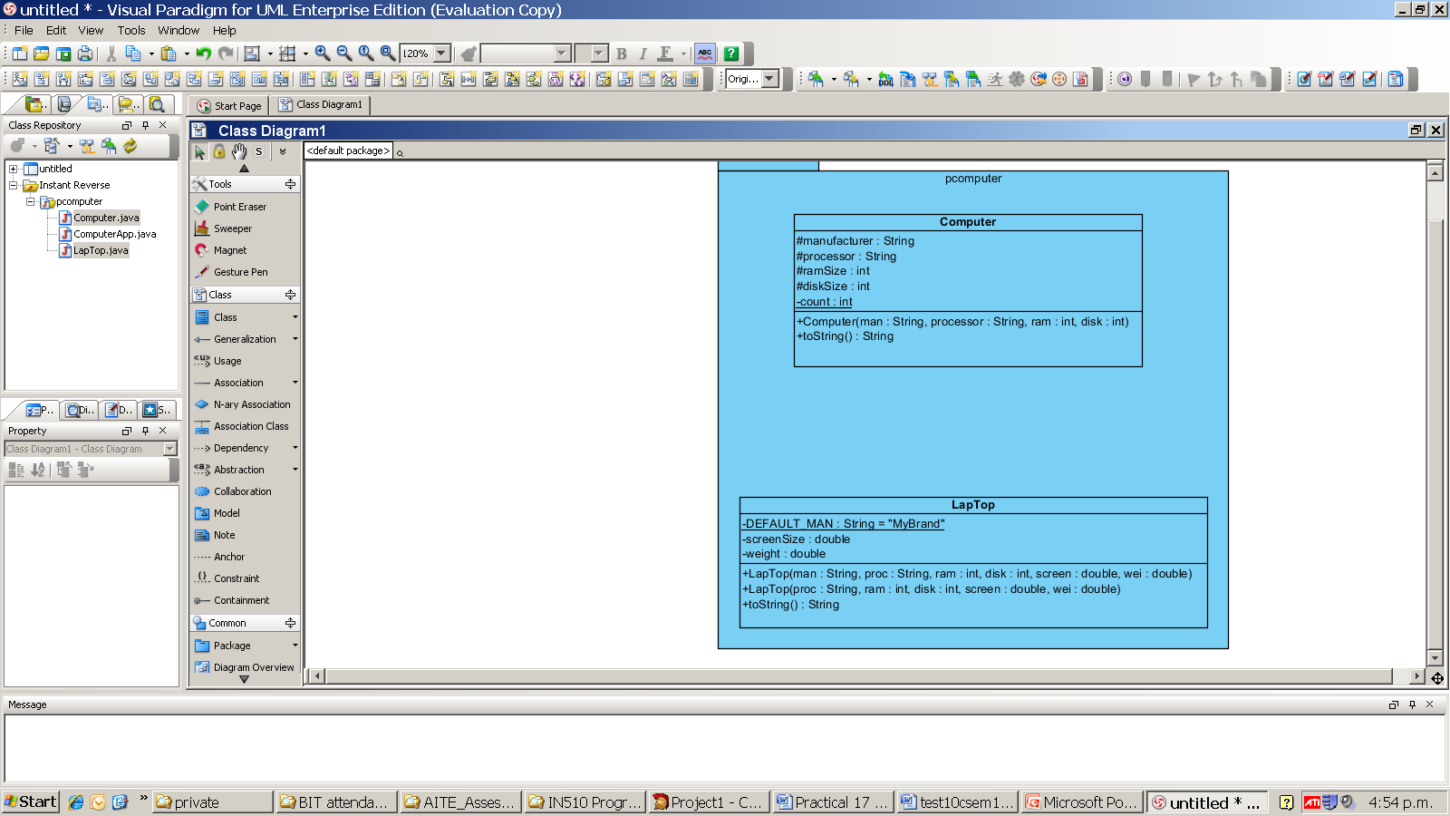
- Create the abstract class Animal, it has an abstract method speak, write a toString method that gives the animal’s name and type and runs the speak method.
The SeaLion constructor should do a super call to its parent constructor.
Domesticated is an interface with a constant and two abstract methods. In the App class create a SeaLion and a Dog and call all of their methods
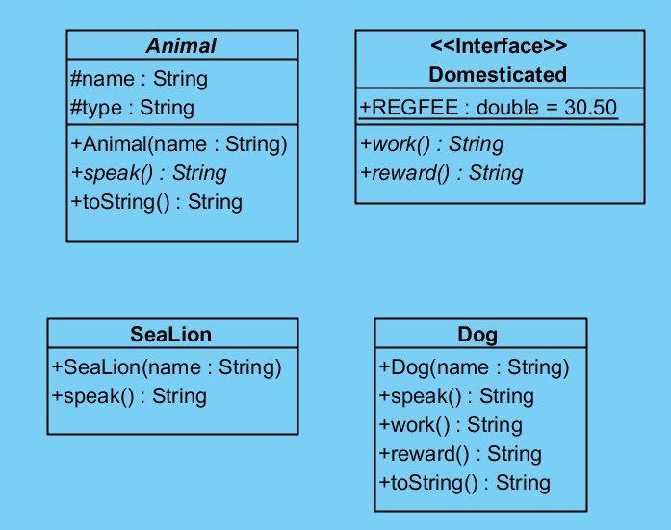
abstract

- Find an interesting dataset for your assignment, you cannot have the same dataset as anyone else in the class.

